



CSPD

Operational Plan 2016 Final Version V17



**Vision**

**A healthier Ireland with a high quality health service valued by all**

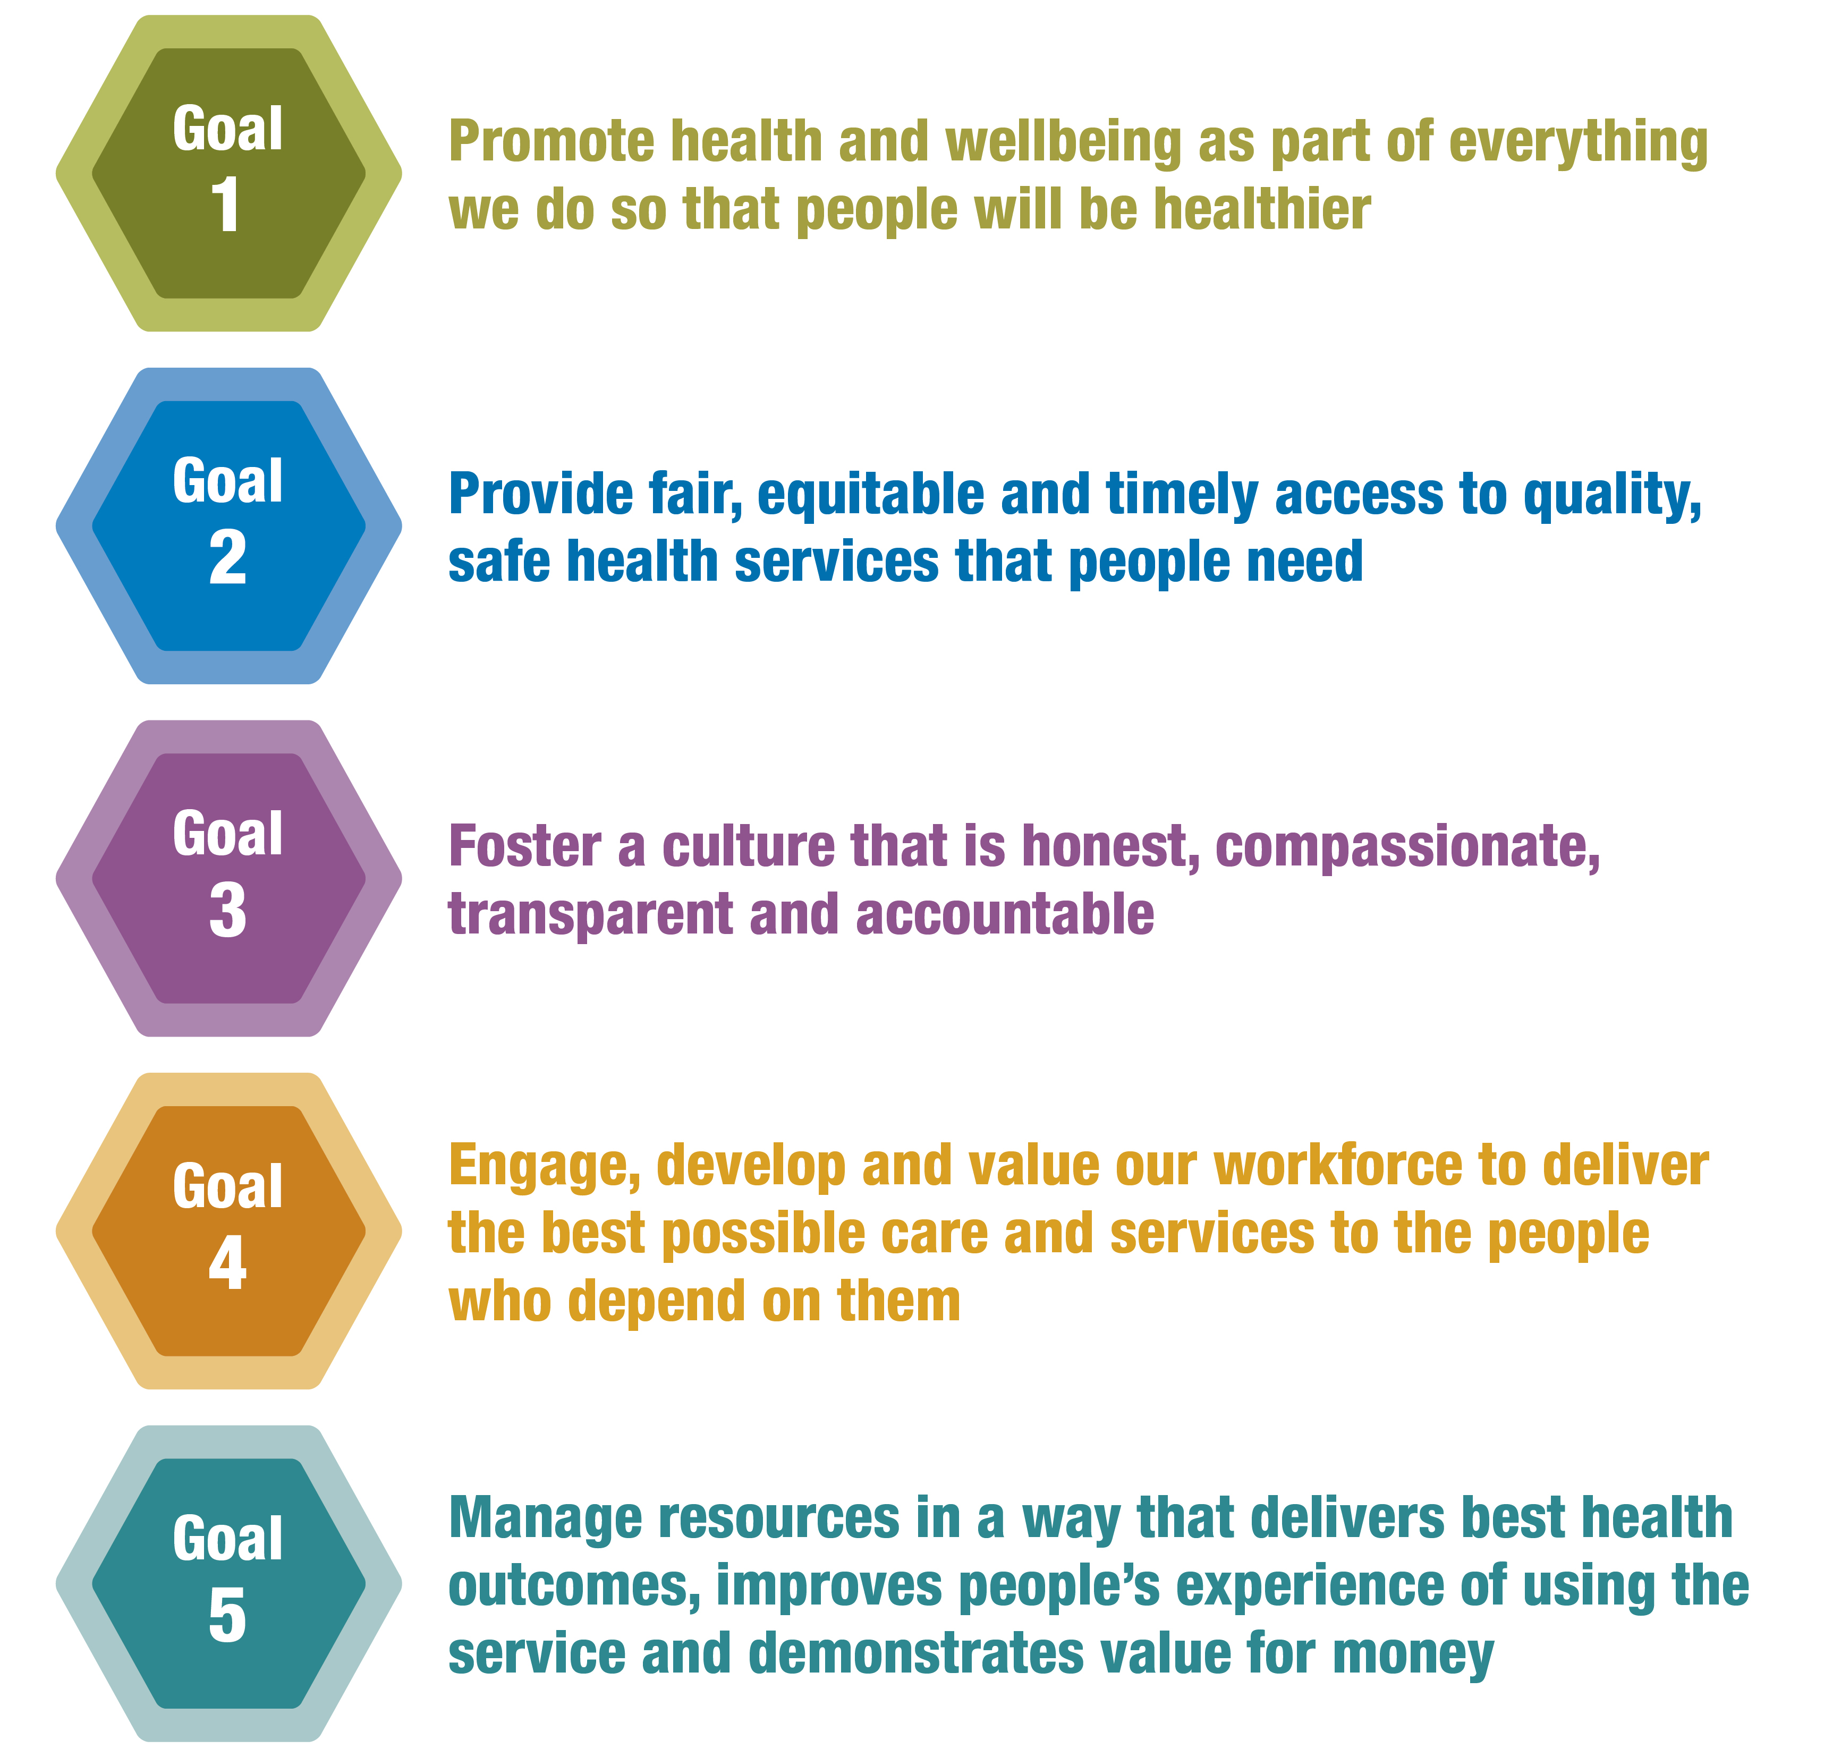Contents



**Care**



**Compassion**



**Trust**



**Learning**

**Values**

**We will try to live our values every day and will continue to develop them**



**Mission**

* **People in Ireland are supported by health and social care services to achieve their full potential**
* **People in Ireland can access safe, compassionate and quality care when they need it**
* **People in Ireland can be confident that we will deliver the best health outcomes and value through optimising our resources**

**Executive Summary………………………………………………………………………………………………………………..3**

**Introduction…………………………………………………………………………………………………………………………5**

**Key Priorities & Actions to Deliver on Goals in 2016………………………………………………………………………....7**

**Goal 1…………………………………………………………………………………………………………………………………7**

**Goal 2…………………………………………………………………………………………………………………………………8**

**Goal 3…………………………………………………………………………………………………………………………………16**

**Goal 4……………………………………………………………………………………………………………………………….17**

**Goal 5…………………………………………………………………………………………………………………………………20**

Executive Summary

|  |  |  |  |
| --- | --- | --- | --- |
| **2016 Available Budget €m** |  | **€54.0m** |  |
| **Clinical and Integrated Care Programmes** |  | €18.9m |  |
| **ONMSD** |  | €35.1m |  |
| TBC |  |  |  |
|  |  |  |  |

The Clinical Strategy and Programmes Division is leading a large scale programme of work to develop a system of integrated care across health and social care services – a major element of health reform in Ireland. This is a long term programme of improvement and change and will involve people at every level of the health services working together to create improved experiences and outcomes for the people in their care, in a way which puts them at the centre of all services. The national clinical and integrated care programmes are central to this reform putting clinical leadership, including nursing and midwifery, at the core of leading improvements across community healthcare organisations (CHO) and hospital groups. This is the first operational plan for the Clinical Strategy and Programme Division. It outlines the key priorities, actions and deliverables for 2016 which are part of a multiyear programme of work.

The CSPD budget for 2016 is €54m. This represents an increase of 22% over 2015. Allocation of the budget is summarised in the table opposite

The Clinical Strategy and Programmes Division (CSPD) has been in operation since 2009, established to improve and standardise patient care nationally, bringing together clinical disciplines, and enabling them to share innovative solutions to deliver greater benefits to every user of HSE services.

The Health Service structural reforms initiated over the last couple of years in the context of the reform programme has the changed the focus for the CSP Division, in this context CSPD needs to reform itself. A critical part of this reform will be to identify and implement an operating model to develop and deliver Integrated Care Programmes (ICP’s), whilst also continuing to support the national clinical programmes.

CSPD is now building on the existing national clinical programmes while also establishing five ICP’s to progress the establishment, enablement and delivery of integrated care across the health and social care system in Ireland;

* prevention and management of chronic disease,
* older persons,
* patient flow,
* children and
* maternity care.

This operating plan sets out the actions we will pursue to progress our 2016 key priorities. It sets actions which will be undertaken directly by CSP or through other HSE divisions in close collaboration with CSPD to progress the delivery of the goals of the HSE Corporate Plan 2015-2017 over the course of the year. Our objective is to provide high quality, sustainable health care grounded in our values of Care, Compassion, Trust & Learning. It is an ambitious programme of work, dependent on the efforts, dedication and expertise of the CSP team and the collaboration and co-operation of colleagues from across the HSE, wider health system, and academia and beyond.

I look forward to working collaboratively with all stakeholders in 2016 to improve how we care and deliver services for our patients and service-users, our staff and the wider population.

**Dr. Áine Carroll**

**National Director for Clinical Strategy and Programmes**

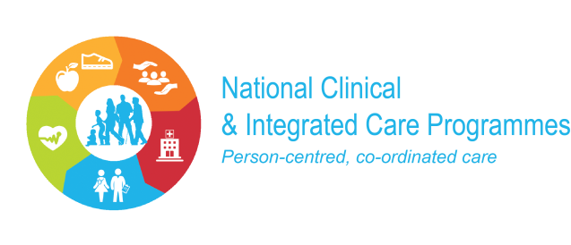



VISION

*To improve quality, access and outcomes for patients and their families through the design of integrated models of care developed by clinicians, social care professionals and management, working together sharing innovative solutions and evidence based best practice*

MISSION

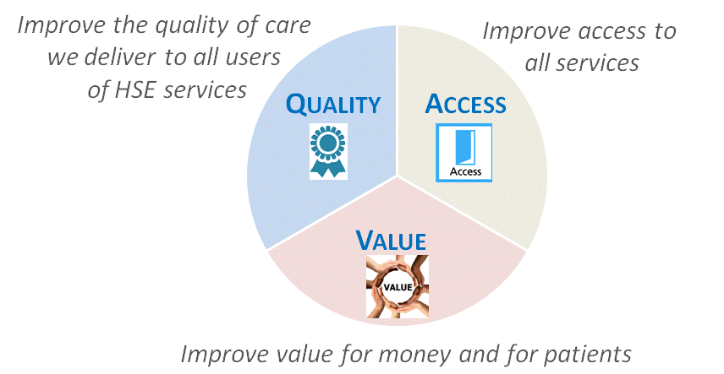

OBJECTIVES



Improving and Reforming Service Delivery

**Clinical and Integrated Care Programmes**

The provision of care, which is provided through our CHO’s, hospital groups and National Ambulance Service must be person centred and coordinated, providing better and easier access to services which are close to where people live. This is a long term programme of improvement and change and will involve people at every level of the health services working together to create improved experiences and outcomes for the people in their care, in a way which puts them at the centre of all services.

In 2016 the clinical and integrated care programmes will lead a number of priority programmes to design, develop and progressively implement models of care which will incorporate cross service, multi-disciplinary care and support which will facilitate the delivery of high quality evidence based and coordinated care. We will work collaboratively with the HSE divisions to ensure the changes implemented are consistent with frameworks, models of care, pathways and guidelines designed by the integrated and clinical care programmes.

The CSPD will continue to progress it’s reform programme, to create an operating framework that brings together healthcare professionals (clinical and management) across all relevant disciplines and to enable them to identify innovative solutions which can deliver increased benefits to every user of our health services, coupled with enabling good governance, accountability and the delivery of sustainable change . To this end, the Division will continue investment in change management and programme management capacity to ensure that the pace and changes required are sustainable and consistent with organisational reform priorities and standards.

Key Priorities in 2016

The **National Clinical Programmes** continue to **modernise** and **improve** the way in which specific areas of health and social care services are provided and delivered by **designing and guiding the implementation** of **standardised models of care**, **clinical guidelines**, **care pathways and associated strategies** through 33 national clinical programmes. This will ensure the availability of clinically led multi-disciplinary teams spreading evidence based effective changes through a consistent national approach to improvement, leading to modernised, standardised, high quality, safe and efficient services.

The **Office of Nursing and Midwifery Services** leads and supports the nursing and midwifery professions to deliver safe, high quality person-centred healthcare that enables people to lead healthier and more fulfilled lives. The work is aligned to legislation and health policy.

The **Integrated Care Programmes** continue to progress the **establishment, enablement and delivery** of five integrated care programmes:

* Patient flow
* Older persons
* Prevention and management of chronic disease
* Children
* Maternity care.

These programmes of work will contribute to:

* Standardised, high quality, safe and efficient health and social care services.
* A health service that is delivered across community healthcare and hospitals in a way that meets the needs of patients, the workforce and other resources, including buildings and equipment, and a health service that is organised to support the patient as they move through the system.
* Clarity about what patients and service users can expect described through defined pathways of care.
* People having a better healthcare experience because of improved co-ordination of their care, clear communication with them, and the provision of care in the most appropriate setting for them in line with best clinical practice.
* People being engaged in the design of healthcare and in implementing solutions.

**Health Service Reform** 2016 will be another important year in the ongoing reform of the health services with a continued focus on progressing programmes of work that have been identified as key to enabling the services to be re-organised. The CSPD will seek to support, contribute to, and influence the reform programmes of the key enabling support functions such as Finance, IT, HR and Workforce planning to ensure the correct business supports are available to deliver the work of the integrated care programmes. The successfully implementation of integrated care is dependent on these key enabling functions engaging and facilitating the work of the ICP’s**.**

**Communications** will be a key and integral component of all CSPD programmes in 2016 involving internal, external and programme communications initiatives. Aligned to the CSPD 'Communications Strategy', communication initiatives will be tailored to support CSPD reform and individual integrated care programmes. The role of digital communications will be a prioritised.

Key Priorities and Actions to Deliver on Goals in 2016

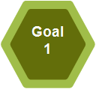

**Promote health and wellbeing as part of everything we do so that people will be healthier**

**Priority 2016**

Work collaboratively with Health and Wellbeing Division to ensure our programmes of work are aligned and re-enforcing in relation to promoting prevention and health and wellbeing as part of everything we do.

|  |  |  |
| --- | --- | --- |
| **Actions 2016** | **End Q** | **Owner** |
| * Where appropriate we will support the Health and Wellbeing to deliver their following actions * Finalise Framework for Brief Intervention/Health Behaviour Change, develop Implementation Plan and commence implementation * Develop implementation plan for risk factor recording in agreed ICT systems in partnership with relevant Divisions and Services * Finalisation of a Self Management Support Framework for Diabetes, Asthma, COPD, and Cardiovascular Disease following consultation and develop an implementation plan * Development of Information Hub for Self Management Support * Implement a feasibility study for Make Every Contact Count Demonstration Project with GPs in Carlow / Kilkenny | Q4 | H&W/ICP-CD |

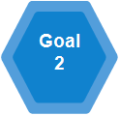

**Provide fair, equitable and timely access to quality, safe health services that people need**

**Integrated Care Programmes:**

**Priority 2016**

The **Integrated Care Programmes** continue to **progress the establishment, enablement and delivery** of five integrated care programmes**:**

**1. Integrated Care Programme for Patient Flow:** Progress a number of priority projects to tackle some of the most pressing patient flow challenges in our health system and improve quality, access and resource utilisation:

* + The planning and phased implementation of a pilot project to design, test and deploy the application of scientific management practices in healthcare to tackle patient flow. This will result in more effective scheduling of both workforce capability and fixed resources to meet patient service demand.
  + Design and phased implementation of new service delivery models and methods – non-emergency service contact number and branding, for example GP imaging initiatives and musculoskeletal physiotherapy services.

|  |  |  |
| --- | --- | --- |
| **Actions 2016** | **End Q** | **Owner** |
| * Establish the Integrated Care Programme for Patient Flow and prioritised work-streams. | Q4 | ICP-PF |
| * Establish, plan and progress the phased implementation of a three year programme to design, test and deploy the application of scientific management practices and related methodologies in healthcare to improve patient flow, initially focusing on acute care. Minimum 2 hospital pilot sites * Merge the Irish Hospital Redesign Programme in to this new 3 year programme. | Q4 | AHD/ICP-PF & CSP |
| * Support the design and phased implementation of new service delivery models and methods   + Establish a project to explore the introduction of a non emergency service number and communication. | Q4 | NAS, AHD, CSP |
| * Support the design and phased implementation of new service delivery models and methods   + Musculoskeletal (MSk) physiotherapy services phased implementation. –-Expand the (MSk) initiative between NCP for Trauma & Orthopaedics and NCP Rheumatology through recruitment of 6 WTE clinical specialist physiotherapists with the aim of further reducing waiting lists in acute hospitals.   + Appoint 0.5 WTE lead to identify and develop pathway for MSk physiotherapy for primary care. | Q4 | NCP’ Rheumatology and NCP & Trauma Orthopaedics |
| * Support the design and phased implementation of new service delivery models and methods - Acute Surgical Assessment Units;   + Prepare for and develop Acute Surgical Assessment Units in two model 4 hospitals. Once implemented evaluate as a proof of concept. | Q4 | NCP - Surgery |
| * Support the design and phased implementation of new service delivery models and methods -National Quality Assurance Intelligence System (NQAIS) for Medicine   + Recruit a Programme Manager to work towards implementation of the National Quality Assurance Intelligence System (NQAIS) for Medicine across all acute hospitals nationally over a 12 month period | Q4 | NCP Acute Medicine |

2. **Integrated Care Programme for Older Persons:** Address the needs of older persons including those with complex requirements through the establishment of a pioneer area. This will implement and evaluate the provision of integrated care services. A set of initial Integrated Care Programme - Older Persons objectives has been determined in the context of the HSE Reform Programme. In that regard, the CHO and Hospital partners, working in conjunction with the ICP OP and NCP OP will establish governance structures and recruit core team members in order to capitalise on existing efforts to integrate and improve care for older persons. This builds on existing service provision across all care providers but seeks to provide a framework for enhanced local integration linked to national governance and include the development of evaluation methodologies as strong components of the programme. By acting as a ‘test and deploy area’ the impact of integrated care can be established in terms of cost, quality and access. This bottom up approach will establish ‘what works’ best in terms of adoption of an integrated care model at a local level, allowing outcome measures to be evaluated.

|  |  |  |
| --- | --- | --- |
| **Actions 2016** | **End Q** | **Owner** |
| The purpose of the Integrated Care Programme for Older Persons (ICPOP) is to augment primary and secondary care services for older persons in the community enabling a shift from a model of acute, hospital-based episodic care to a model that reflects increased co-ordination and care planning based on the needs of the older person. Given the ageing demographics there is an urgent need to build capacity in the provision of healthcare services that can meet this change in the model in both community and acute services. Work is already well established in Cork and Limerick, while programmes are being initiated in conjunction with Tallaght and Our Lady of Lourdes (OLOL) Hospitals. The priority in 2016 is developing this programme across 4 pioneer sites (CHO 7, Tallaght Hospital; CHO 8, OLOL; CHO 4, Cork University Hospital (CUH); CHO 3 University College Hospital Limerick (UCHL) which will commence the implementation of the integrated care programme in 2016. Social care services will lead the process which is multi-agency and multi-divisional.  Engage with CHO and Hospital Group Leadership to prepare pioneer areas in working towards shifting model of care towards community based services and building on local initiatives and in combination with ICP OP framework.   * Establish governance structures in Pioneer Areas (CHOs 3, 4, 7, 8). * Support establishment of local Integrated Care Team. * Develop new clinical roles and structures to support ICP OP. * Establish project work streams to develop and evaluate model. | Q4 | ICP-OP& Social care |
| Support enhancement of care pathways and work towards a model of integrated care in non-pioneer areas (in conjunction with National Clinical Programme Older Persons) including developing appropriate governance and evaluation mechanisms.  **CHO Specific Actions to Implement ICPOP**  **CHO Action** |  |  |
| CHO 1 Recruit 6 WTE multidisciplinary team in conjunction with Sligo General Hospital to support development of enhancing care pathways for older persons. | Q4 | CHO 1 |
| CHO 2 Support development of enhancing care pathways for older persons in conjunction with ICPOP and National Clinical Care Programme, Older persons. | Q4 | CHO 2 |
| CHO 3 Continue to develop integrated care pathways building on existing structures and relationships in the area. | Q4 | CHO 3 |
| CHO 4 Recruit 4.0 WTE multidisciplinary team in conjunction with Cork University Hospital to support development of enhancing care pathways for older persons. | Q4 | CHO 4 |
| CHO 5 Support development of enhancing care pathways for older persons in conjunction with ICPOP and National Clinical Care Programme, Older persons. | Q4 | CHO 5 |
| CHO 6 Recruit 5.0 WTE; 1 Consultant Geriatrician and multidisciplinary team to support development of enhancing care pathways for older persons. | Q4 | CHO 6 |
| CHO 7 Recruit 6.0 WTE 1Consultant Geriatrician and multidisciplinary team in conjunction with Tallaght Hospital to support development of enhancing care pathways for older persons. | Q4 | CHO 7 |
| CHO 8 Recruit 7.0 WTE multidisciplinary team in conjunction with Our Lady of Lourdes Hospital to support development of enhancing care pathways for older persons. | Q4 | CHO 8 |
| CHO 9 Recruit 6.0 WTE; 2 WTE Consultant Geriatrician posts and multidisciplinary team in conjunction with north side Dublin Hospitals to support development of enhancing care pathways for older persons. | Q4 | CHO 9 |

3. **Integrated Care Programme for Prevention and Management of Chronic Disease:** Facilitate the implementation of integrated care by the phased linking of CHOs and hospital groups in demonstrator projects. These will target the delivery of chronic disease management programmes and incorporate health promotion, illness prevention and self management.

|  |  |  |
| --- | --- | --- |
| **Actions 2016** | **End Q** | **Owner** |
|  |  |  |
| * Implement the Chronic disease **demonstrator projects:** * Appoint the **2015 approved posts** for respiratory, heart failure and diabetes | Q1 | ICP-CD/Primary Care |
| * Implement the Chronic disease **demonstrator projects**; **2016 approved posts** - Develop and recruit new clinical roles and structures to support Integrated care implementation in CHO (48 posts): * 19 additional senior dietitian posts –  (18 senior dietician posts and 1 Clinical Specialist Dietician) to be appointed to priority areas to provide diabetic structured education programmes (0.5 WTE) and support diabetes cycle of care (0.5 WTE). * 9 additional podiatrist posts to be appointed to priority areas to implement footcare model to support diabetes cycle of care. * 9 additional clinical nurse specialist posts to be appointed to priority areas to fill the 9 priority gaps in services for diabetes. * 6 additional respiratory demonstrator sites to be developed with the appointment of 6 clinical nurse specialist posts and 6 senior physiotherapy posts. | Q4 | ICP-CD/Primary care |
| * Design and develop the Integrated Model of Care for Prevention and Management of Chronic Disease (ICPCD) | Q4 | ICP-CD |
|  |  |  |
| * Design and implement software for clinical nurse specialists in integrated care chronic disease demonstrator projects to support data sharing, case management and performance reporting. * Design and develop a system for clinical data sharing for chronic disease between primary and secondary care | Q4  Q4 | ICP –CD/Primary Care/Office of the Chief Information Officer  ICP-CD/Primary Care/OCIO |
| * Provide support of GP and Pharmacy sessions to contribute to the development of the Self Management Support Framework. | Q4 | ICP-CD/Primary care/Health and Wellbeing |
| * Enable the release of 500 Primary Care staff for brief intervention training. | Q4 | ICP-CD/Primary care/Health and Wellbeing |
| * Rollout of the National COPD Collaborative in association with the Quality Improvement Division and the Royal College of Physicians of Ireland. | Q4 | ICP-CD |
| * Collaborate with the Office of the Chief Information Officer (OCIO) in the design of chronic disease registries for use in primary, secondary and continuing care. * Collaborate with the Office of the Chief Information Officer (OCIO) in the design of a Predictive Modelling and Risk Stratification approach for patients with one or more chronic diseases. | Q4  Q4 | ICP-CD/OCIO  ICP-CD/OCIO |
| * Progress the implementation of the Diabetes National Clinical Programme and Diabetes Cycle of Care making best use of the existing Integrated Care Diabetes Clinical Nurse Specialists. * Coordinate and provide structured education programmes for patients with diabetes | Q4  Q4 | NCP Diabetes/Primary Care  NCP Diabetes |
| * Progress a study of outcomes for patients with acute asthma in collaboration with Clinical Strategy and Programmes. | Q4 | NCP Asthma/Primary Care |

**4. Integrated Care Programme for Children:** Will work with and build on the models of care already developed by the National Clinical Programme for Paediatrics and Neonatology. It will aim to identify and progress a number of priority projects to integrate community and hospital services to enable children to have a high standard of care at any point in their care journey. It will aim to design a new service delivery model with the phased implementation of a pilot a consultant delivered paediatric service.

|  |  |  |
| --- | --- | --- |
| **Actions 2016** | **End Q** | **Owner** |
| * Establishment of the Integrated Care Programme for Children and associated work-streams. | Q4 | ICP-C |
| * Progress implementation, on a pilot basis, of a general paediatric consultant-delivered service to ensure greater efficiencies in acute care delivery and scheduled care following the review of paediatric and neonatology services; and framework for future development in line with the national model of care for Paediatrics and Neonatology. * Complete project scoping – * Recruit three consultant general paediatricians who will work in a new service delivery model moving towards full implementation of a consultant-delivered service | Q1  Q4 | ICP-C  ICP-C |
| * Support the Health and Wellbeing Division in the development of a antenatal hepatitis B screening and perinatal hepatitis B prevention programme in Ireland | Q2 | ICP-C |
| * Develop of an integrated care pathway for children with Duchenne Muscular Dystrophy | Q4 | ICP-C |
| * Develop a detailed national implementation plan for targeted hip ultrasound screening programme for infants at increased risk of developmental dysplasia of hip (DDH) | Q4 | ICP-C |

**5. Integrated Care Programme for Maternity Services:**

|  |  |  |
| --- | --- | --- |
| **Actions 2016** | **End Q** | **Owner** |
| * Review and consider the establishment of an Integrated Care Programme for Maternity Services taking into consideration the Department of Health Maternity Strategy and its implementation plan. | Q4 | OND |
|  |  |  |
|  |  |  |
|  |  |  |
|  |  |  |

**Clinical and Integrated Care Programme impact evaluation**

**Priority 2016**

|  |  |  |
| --- | --- | --- |
| **Actions 2016** | **End Q** | **Owner** |
| * Establish a framework to enable CSP to commission external evaluation of the work the Clinical and Integrated care programmes * Commission external evaluation of the work of selected Clinical and Integrated care programmes | Q2  Q2 | OND  OND |

**National Clinical Programmes**

**Priority 2016**

The **National Clinical Programmes:** Continue to modernise and improve the way in which specific areas of health and social care services are provided and delivered by designing and guiding the implementation of standardised models of care, clinical guidelines, care pathways and associated strategies through 33 national clinical programmes. This will ensure the availability of clinically led multi-disciplinary teams spreading evidence based effective changes through a consistent national approach to improvement, leading to modernised, standardised, high quality, safe and efficient services.

|  |  |  |
| --- | --- | --- |
| **Actions** | **End Q** | **Owner** |
| The **National Clinical Programmes** are in the process of developing programme plans for 2016 and beyond with the support of the CSPD PMO. The final programme plans will be informed by and aligned to the agreed priorities of the division as set out by the CSPD SMT. This process will be completed by the End of Q1 2016.  The list below identifies deliverables of some National Clinical Programmes but a more exhaustive list will be compiled on completion of the planning process. | Q1 | NCP’s/PMO |
| **National Clinical Programme for Acute Coronary Syndrome**   * Publication of Model of Care for Non- STEMI ACS Patients | Q4 |  |
| **National Clinical Programme for Chronic Obstructive Pulmonary Disease (COPD)**   * Publication of Model of Care for Pulmonary Rehabilitation Services | Q2 |  |
| **National Clinical Programme for Dermatology**   * Publication of Model of Care for Dermatology Services | Q4 |  |
| **National Clinical Programme for Epilepsy**   * Publication of Model of Care for Epilepsy Services | Q1 |  |
| **National Clinical Programme Assessment and management of self-harm presentations to ED**   * Recruitment and appointment of vacant CNS posts completed * education/training programme implemented for staff | Q4  Q4 |  |
| **National Clinical Programme First Episode Psychosis**   * Appoint a Clinical Lead * Behavioural family therapy in place for all families on first episode psychosis programme * Develop an SOP, training and supervision plan to support staff to deliver individual placement support (IPS) * Develop an SOP, training and supervision plan to support staff to deliver CBT for psychosis | Q3  Q1  Q4  Q4 |  |
| **National Clinical Programme for Eating Disorder**   * Multi-disciplinary group to draft model of care for eating disorders | Q3 |  |
| **National Clinical Programme for ADHD in children and adults**   * Scope and develop a clinical programme for ADHD in children and adults | Q4 |  |
| **National Clinical Programme for Dual Diagnosis**   * Scope and develop a clinical programme for dual diagnosis (mental illness and substance misuse including alcohol) | Q4 |  |
| **National Clinical Programme for Neurology**   * Publication of Model of Care for Neurology Services | Q1 |  |
| **National Clinical Programme for Ophthalmology**   * Publication of Model of Care for Eye Services | Q3 |  |
| **National Clinical Programme for Paediatrics & Neonatology**   * Publication of Model of Care for Paediatric Services * Publication of Model of Care for Transition from Paediatric to Young Adult Diabetes Care * Publication of Improving Standards for General Paediatric Surgery Document * Publication of Model of Care for Urgent & Ambulatory Care Centres * Implement PEWS in all hospitals | Q1  Q1  Q1  Q2  Q4 |  |
| **National Clinical Programme for Radiology**   * Radiology National Clinical Programme - Support the Primary Care Division to extend direct access for GPs to ultrasound and x-ray, map and identify existing access gaps for GP direct access to x-ray. |  |  |
| **National Clinical Programme for Rehabilitation**   * Publication of Model of Care for Rehabilitation Services | Q2 |  |
| **National Clinical Programme for Rheumatology**   * Publication of Model of Care for Rheumatology | Q2 |  |

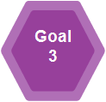

**Foster a culture that is honest, compassionate, transparent and accountable**

**Patient Experience**

**Priority 2016**

Improve Patient experience by improving knowledge of patients and their care requirements and communicating better with the users of our Health and Social Care Services

|  |  |  |
| --- | --- | --- |
| **Actions 2016** | **End Q** | **Owner** |
| * Establish the implementation on a phased basis a care and compassion MDT training programme | Q4 | OND |
| * Establish a project to develop a patient/service user perspective narrative | Q4 | OND |

**Risk Management**

**Priority 2016**

Manage risk within the Clinical and Integrated Care programmes through the ongoing development of risk management processes. Work to enhance the capability of staff in relation to the management of risk through education and training

|  |  |  |
| --- | --- | --- |
| **Actions 2016**   * Develop, agree and implement an Interim Risk and Issue Management process for ICPs and agree with CSPD SMT - (in the absence of finalised governance structures) * Develop and agree an interim Risk and Issue Management process for NCP’s | End Q  Q1  Q1 | **Owner**  PMO  PMO |
| * In collaboration with QAV Division and pending finalisation of the HSE Risk Framework module in ProjectVision, develop the CSPD Divisional Risk and Issue Management processes and review and update the CSPD updates for the Corporate Risk Register * Implement and manage approved finalised ICP & NCP Risk and Issue management processes. | Q2  Q2 | PMO/OND  PMO |

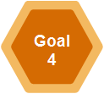

**Engage, develop and value our workforce to deliver the best possible care and services to the people who depend on them**

**Communication**

**Priority 2016**

Engage and encourage through multiple communication initiatives people at every level of the health services to work together to create improved experiences and outcomes for the people in their care, in a way which puts them at the centre of all services.

Ensure that all stakeholders and members of the workforce are aware of their role in the planned changes of the ICPs and the impact for service users.

Foster an appreciation of the value of the individuals teams and workforce involved in the Clinical and Integrated care programmes through recognition of successes and achievements in all relevant communications.

|  |  |  |
| --- | --- | --- |
| **Actions 2016** | **End Q** | **Owner** |
| Develop and implement ongoing communication to create and encourage awareness, involvement, decision to participate and acceptance (AIDA).Inform workforce about new models and developments.   * + Internal communications     - Quarterly eZine     - Internal HSE staff channels (inc 'Health Matters')     - bulletins     - staff   + External / Corporate communications     - Digital comms (currently: twitter, website, etc)     - Specialist press features     - Bespoke comms presentations * Develop communication initiatives with supporting communication tools to facilitate the ICPs to progress their programmes of work. This includes the provision of consultancy to all areas, individuals and programmes within CSPD in the development of communication initiatives that support the Integrated Care Programmes   + Specifically, communications for Pioneer Areas includes toolkits, guides, staff flyers, posters, Q&A's, service user communication pieces, information portals, etc   + Communications for specific ICPs * Develop a Clinical and Integrated Care digital communications strategy- establish a phased implementation plan * Communicate with the workforce the achievements of the ICPs and NCPs via CSPD internal communications and inclusion in external communications as appropriate (newsletter features, twitter, emails, website features, specialist press, etc) * Develop events - including Integrated Care Conference and international care conference enabling awareness and sharing of developing practice and experiences of integrated care developments | Q4  Q4  Q4  Q4  Q3/Q4 | CSP reform comms/OND  CSP reform comms  CSPreform comms/OND  CSP reform comms / OND  OND |

**HSE People Strategy**

**Priority 2016**

We will proactively support the implementation of the HSE People Strategy 2015-2018 which has been developed in recognition of the vital role the workforce plays in delivering safer and better healthcare. This Strategy is underpinned by a commitment to engage, develop, value and support people, thereby creating a culture of high trust between management and employees, supporting the achievement of performance. The CSP Division will fully support its implementation across its team.

|  |  |  |
| --- | --- | --- |
| **Actions 2016** | **End Q** | **Owner** |
| * Establish a Staff Development Programme across CSP team. | Q4 | OND |

**Office of Nursing and Midwifery Services (ONMSD)**

**Priority 2016**

The purpose of the Office of Nursing and Midwifery Services (ONMSD), is to strategically lead and support the development of capacity and capability of nursing and midwifery teams inclusive of health care assistants and maternity care assistants to deliver safe, compassionate, high quality person centred healthcare that enables people to improve their quality of life and wellbeing.

|  |  |  |
| --- | --- | --- |
| **Actions 2016** | **End Q** | **Owner** |
| * Undertake a pilot  of the Framework for Staffing and Skill Requirements (phase 1), in conjunction with acute hospitals, for the nursing workforce in a range of major specialties in  general and specialist adult hospital medical and surgical care settings, to test the capability of the framework to deliver on its intended outcomes. ***(Held Funding DoH €2m)*** * Provide education to increase the number of nurses and midwives who may prescribe medicinal products. * Provide education to increase the number of nurses registered who may prescribe x-ray (ionising radiation). * Provide clinical education to maximise the development of ED and AMAU nurses’ skills and competence to undertake advanced clinical assessment, interpretation and treatment in a standardised range of skills to improve patient flow. * Provide mandatory adaptation programmes for overseas nurses who have been recruited and must complete adaptation before they may register with the National and Midwifery Board of Ireland. * Continued development and implementation of a national operating framework and a suite of Quality Care Metrics for the professions of nursing and midwifery across all care groups in Ireland. * Continued roll out of the coverage of the Caring Behaviours Assurance Systems Ireland (CBAS-I ®) to other acute hospital sites nationally * Publish and commence implementation of the Intellectual Disability Nursing Strategy * Examine the potential to maximise recruitment and retention of nurses and midwives from within Ireland which includes the provision of Return to Nursing and Return to Midwifery Practice programmes * Continued roll out of the Compassionate Care Programme in all seven hospital groups for CNM2s. * Continue to build leadership capacity and capability for nurses and midwives by further supporting the development of programmes and examining opportunities for integrated programme development. * Review the potential role of maternity care assistants in Ireland as per the HIQA/HSE Implementation Plan actions * Commission the provision of education for anaesthetic and pre admission nurses/midwives in the service settings * Support the Clinical Strategy Programmes by providing individual staff resources leading on specific aspects of programmes as well as the collective contribution of the ONMSD to the integrated care programmes. * Collaboration with relevant stakeholders to implement the following agreed and future directional plans for nurses and midwives :   + A Vision for Psychiatric/Mental Health Nursing, a shared journey for mental health care in Ireland 2012   + Strategy and Education Framework for nurses caring for patients with cancer in Ireland.   + National Maternity Strategy (when published) * Review and update National Best Practice and Evidence Based Guidelines for Wound Management. | **Q 4** | **ONMSD** |

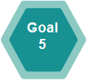

**Manage resources in a way that delivers best health outcomes, improves people’s experience of using the service and demonstrates value for money**

**Operating framework and organisation structure**

**Priority 2016**

Implement an operating framework and organisation structure to support the reform programme, and to support the establishment and phased implementation of integrated care.

|  |  |  |
| --- | --- | --- |
| **Actions 2016** | **End Q** | **Owner** |
| * Engage with the Divisions, CHO’s and HG’s to agree and implement a governance structure to support the design and implementation of Integrated Care |  | SMT |
| * Recruit resources to support the CSP team and ICP programme, and support the delivery of change | Q2 | SMT |
| * Collaborate with QID to utilise their Framework for improving Quality in to ICP and NCP programme planning | Q4 | PMO |
| * Centre reform programme – establish programme and key work streams | Q1 |  |
| * Develop a PMO Framework as follows:   *Initiate Phase*   * Support CSPD Operating Model * Develop and agree PMO Charter * Develop and agree PMO Communication and Engagement Model * NCP & ICP 2016 Programme Planning * NCP Prioritisation & Alignment - A framework for ensuring that the work of the NCP’s is prioritised and aligned to broader HSE strategic objectives and priorities will be developed for approval   *Plan Phase*   * Develop and agree PMO Handbook including a SMT assurance process for documents requiring approval * Develop and agree PMO Reporting Framework   *Implementation Phase*   * Implement PMO Reporting Framework * Develop resource requirements for BAU PMO and ICPs * Implement PMO processes, tools and standards * Migrate Programmes to Vision   *Complete*   * Implementation Support * Monitoring | Q1  Q1  Q1  Q3/Q4  Q4 | GM PMO  GM PMO  SMT  GM PMO  GM PMO |

**Activity Based Funding**

**Priority 2016**

Support the transition to an Activity Based Funding model through the development of the 5 integrated care programmes.

|  |  |  |
| --- | --- | --- |
| **Actions 2016** | **End Q** | **Owner** |
| * Work with the Hospital pricing office as required to support the roll out of their ABF programme | Q4 | ICP/NCP |

**Non Cancer Drug Management Project**

**Priority 2016**

Support the planning and transition of Non Cancer Drug Management Project to a new model based on the Cancer drug model

|  |  |  |
| --- | --- | --- |
| **Actions 2016** | **End Q** | **Owner** |
| A non-Cancer Drug Management Programme will be established in 2016 to develop and improve the care provided to patients receiving treatment with non-cancer drugs. This national management system will be set up so that the health service can continue to provide quality treatment to patients within difficult budgetary conditions.  The national management system will facilitate:   * National oversight of the expenditure on high-cost drugs, allowing for coordinated planning and potentially national approaches to provision of non-cancer drugs. * Detailed information about drug utilisation as well as condition incidence and prevalence. * A mechanism for assuring adherence to national drug protocols, which is a key quality and patient safety objective for the HSE.   This programme will be developed in a phased manner. | Q4 | OND |

**Policies, Procedures, Protocols and Guidelines (PPPG)**

**Priority 2016**

**Sponsor and support Policies, Procedures, Protocols and Guidelines (PPPG)**

|  |  |  |
| --- | --- | --- |
| **Actions 2016** | **End Q** | **Owner** |
| **Policies, Procedures, Protocols and Guidelines (PPPG)**   * Participate nationally in developing a national HSE policy framework for PPPGs including education training and support.This will support the implementation of NCEC prioritised national clinical guidelines, clinical audit and standards for clinical practice guidance. | Q4 | OND |
|  |  |  |

**P Health Innovation hub**

**Priority 2016**

|  |  |  |
| --- | --- | --- |
| **Actions 2016** | **End Q** | **Owner** |
| * CSPD will support the HSE to participate in the governance arrangements of this initiative, to support it to progress its key objectives as they converge with the HSE’s aim of nurturing, supporting and developing innovation for the benefit of its service users, workforce and systems. | Q4 | OND |

**Information Communication Technology (ICT)**

**Priority 2016**

Work collaboratively with and support the Office of the Chief Information Officer to develop new programmes which will change the way services are delivered and provided by utilising the capability of digital technology including:

**Electronic health record**

Mobilise the programme to acquire and implement a National Electronic Health Record solution set.

|  |  |  |
| --- | --- | --- |
| **Actions 2016** | **End Q** | **Owner** |
| * To provide a National Electronic Health Record system for Ireland * Engagement with key clinical stakeholders to develop a strategic Business Case * Leveraging the Integrated Services Framework to deliver a standards based set of solutions * Deploy portal technology as an early solution to release existing clinical data (2016 – 2017) * Procure an Acute EHR – First deployment NCH (2016 – 2017); | Q4 | OCIO/OND |
|  |  |  |

**Health Business Services**

The objective of Health Business Services (HBS) – the business division of the HSE, is to ensure that all health services have access to a range of common support business services on a shared basis thus enabling operations to focus attention on core service delivery.

**Priority 2016**

HBS places a strong emphasis on the delivery of compliant services to customers by ensuring they are in line with national EU directives, legislation and regulations, and this area will be developed in 2016.

Working Relationships will be further enhanced through a Business Partnership Arrangement (BPA) between the HBS Functions (Procurement, Estates, Finance, HR and Enterprise Resource Planning) and Clinical Strategy & Programmes Division.[CSP] The BPA will outline the quantum of support business services that the HBS functions will provide to CSP during 2016.